FRUITS
MEYVELER

Orange : portakal
Banana : muz
Watermelon: karpuz
Melon: kavun
Apple : elma
Grape : üzüm
Lemon : limon
Cherry : kiraz
Peach : şeftali
Strawberry : çilek

Pineapple : ananas
-----------------------------------------------------------------
I like… : severim ( I like apples : Ben elmaları severim )
I don’t like… : sevmem ( I don’t like pineapples : Ben ananas sevmem)
Do you like…. : Sever misin ?
A: Do you like lemon ? (Sen limon sever misin )
B: Yes , I do
A: Do you like melon ? ( Sen kavun sever misin ?)
B : No , I don’t.
----------------------------------------------------------------------------
How many : Kaç tane

How many apples are there ? 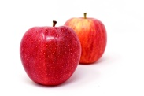
Two apples.
How many oranges are there ? 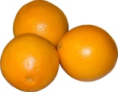
Three oranges.

