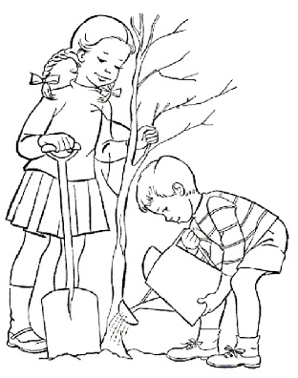
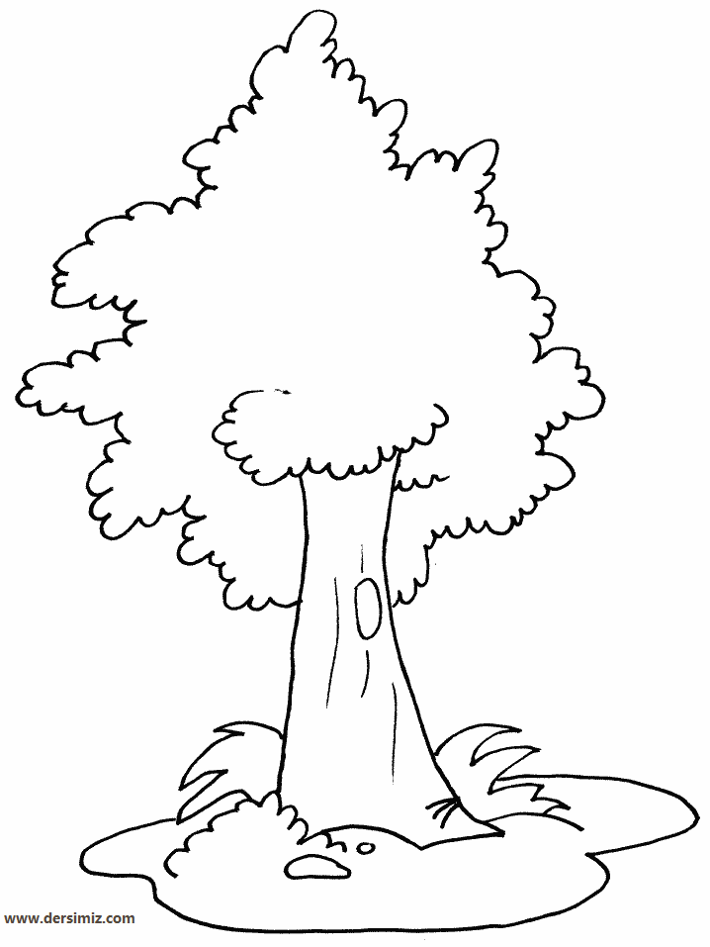
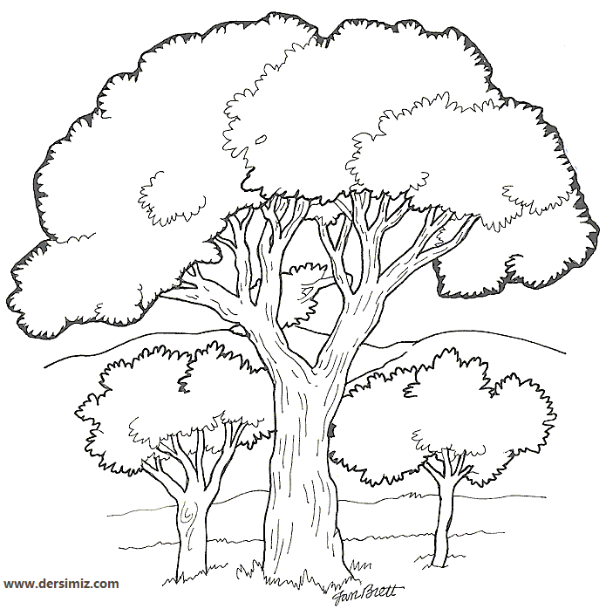

Yukarıdaki görsellerden faydalanarak bir öykü yazınız. Konu doğayı korumak. Öykünüze başlık koymayı unutmayınız.Yazım kurallarına dikkat edelim.

……………………………………………………………………………..
………………………………………………………………………………………………………………………………………………………………………………………………………………………………………………………………………………………………………………………………………………………………………………………………………………………………………………………………………………………………………………………………………………………………………………………………………………………………………………………………………………………………………………………………………………………………………………………………………………………………………………………………………………………………………………………………………………………………………………………………………………………………………………………………………………………………………………………………………………………………………………………………………………………………………………………………………………………………………………………………………………………………………………………………………………………………………………………………………………………………………………………………………………………………………………………………………………………………………………………………………………………………………………………………………………………………………………………………………………………………………………………………………………………………………………………………………………………………………………………………………………………………………………………………………………………………………………………………………………………………………………………………………………………………………………………………………………………………………………………………………………………………………………………………………………………………………………………………………………………………………………………………………………………………………………………………………………………………………………………………………………………………………………………………………………………………………………………………………………………………………………………………………………………………………………………………………………………………………………………………………………………………………………………………………………………………………………………………………………………………………………………………………………………………………………………………………………………………………………………………………………………………………………………………………………………………………………………………………………………………………………………………………………………………………………………………………………………………………………………………………………………………………………………………………………………………………………………………………………………………………………………………………………………………………………………………………………………………………………………………………………………………………………………………………………………………………………………………………………………………………………………………………………………………………………………………………………………………………………………………………………………………………………………………………………………………………………………………………………………………………………………………………………………………………………………………………………………………………………………………………………………………………………………………………………
Yazar :

