**FRUITS**

What is this?

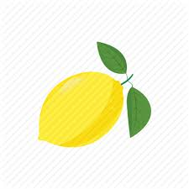

What is this ?

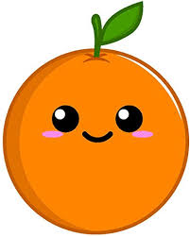

What is this ?

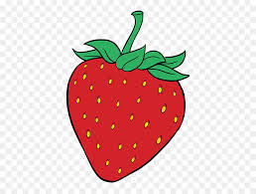

What is this ?

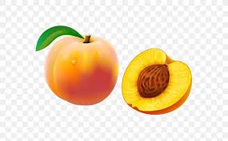

What is this ?

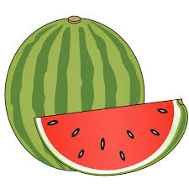

What is this ?

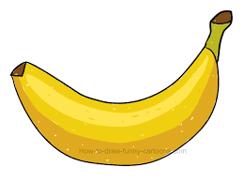

What are THESE ?

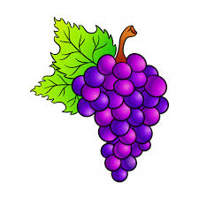

What is this ?

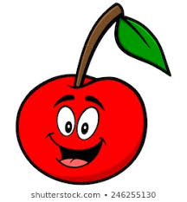,

What is this ?

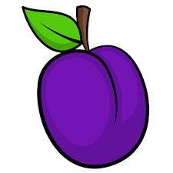

What is this ?

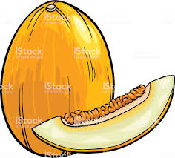

**IMPERATIVES**

**Eat your melon!**

**Come here!**

**Finish your grapes!**

**1-………… your plum! (eat)**

**2-……….. this watermelon! (eat)**

**3-…….. your cherry! (finish)**