**ANIMALS**

|  |
| --- |
|  |

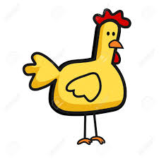 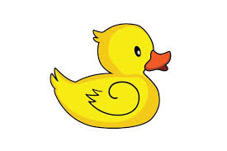

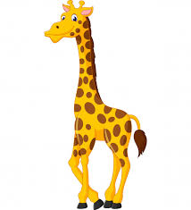 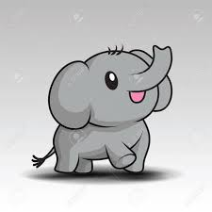

|  |
| --- |
|  |

|  |
| --- |
|  |

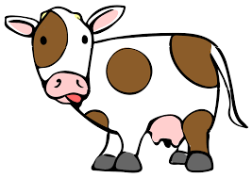 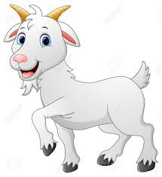

|  |
| --- |
|  |

|  |
| --- |
|  |

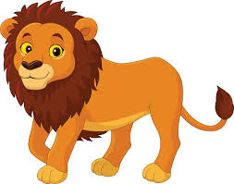 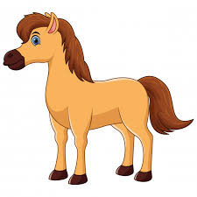

|  |
| --- |
|  |

|  |
| --- |
|  |

|  |
| --- |
|  |

|  |
| --- |
|  |

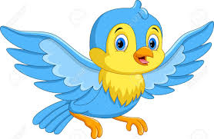 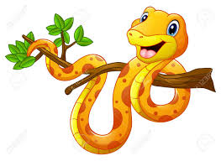

**LIKE/DON’T LIKE**

* What animal do you like?
* What food do you like?
* What fruit do you like?

**Can-Can’t**

I can swim,but I can’t run fast.

**What can you do?**