NUMBERS ACTIVITY
1-How many legs does the duck have ?
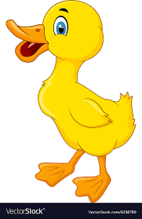 a)3 b)4 c)2

2-How many legs do ducks have ?
a)5 b)4 c)3

3-How many legs does the cat have ?
a)5 b)4 c)5

4-How many legs do the dogs have ?
a)5 b)6 c)8

5-How many arms does the monkey have ?
a)2 b)3 c)4

6-How many legs does the bird have ?
a)2 b)3 c)4

