Let’s write their names under the pictures.
Kişilerin isimlerini resimlerinin altlarına yazalım.
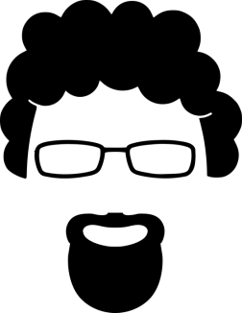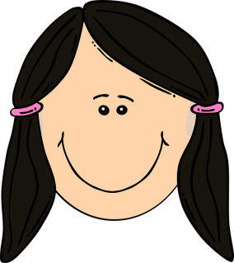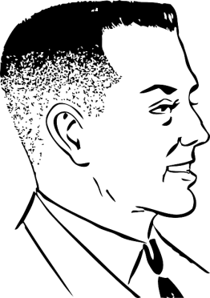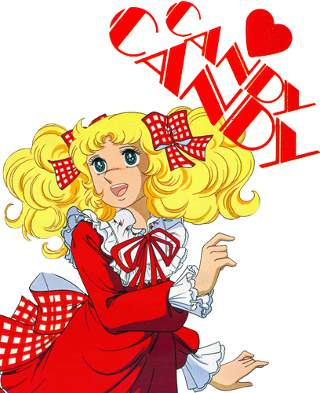
……………………… …………………….. ………………………….. ………………………………..

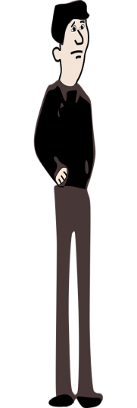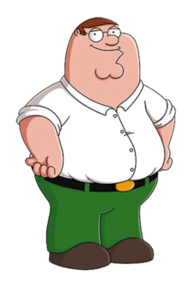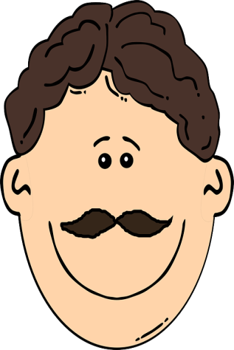
……………………….. …………………………….. ………………………………. ………………………………
- Clarke is seventeen years old. She has blonde hair and blue eyes.She is beautiful.
- Octavia is a student. She has straight dark hair. She has black eyes.
- Lincoln is a waiter. He has short dark hair.
- Bellamy is thin. He is tall. He has dark hair.
- Kane is a chef. He has curly hair. He has a beard. He wears glasses.
- This is Jaha. He has a moustache. He has vawy hair.
- This is Monty. He has Brown hair. He is wearing a tie . He has a suitcase. He is handsome.
- This is John. He is short and fat. He is wearing a White shirt and green trousers.

