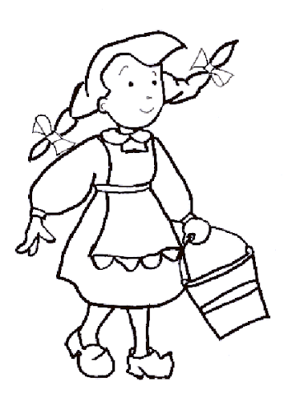
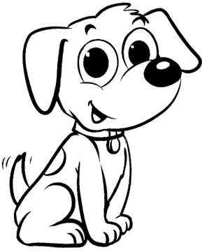
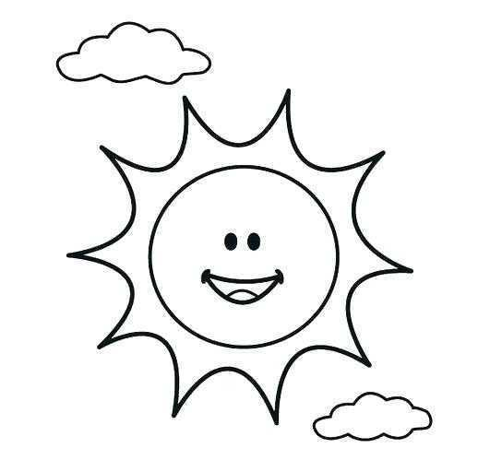
Yukarıdaki görsellerden faydalanarak bir öykü yazınız. Konu hayvanları korumak. Öykünüze başlık koymayı unutmayınız.Yazım kurallarına dikkat edelim.

……………………………………………………………………………..
……………………………………………………………………………………………………………………………………………………………………………………………………………………………………………………………………………………………………………………………………………………………………………………………………………………………………………………………………………………………………………………………………………………………………………………………………………………………………………………………………………………………………………………………………………………………………………………………………………………………………………………………………………………………………………………………………………………………………………………………………………………………………………………………………………………………………………………………………………………………………………………………………………………………………………………………………………………………………………………………………………………………………………………………………………………………………………………………………………………………………………………………………………………………………………………………………………………………………………………………………………………………………………………………………………………………………………………………………………………………………………………………………………………………………………………………………………………………………………………………………………………………………………………………………………………………………………………………………………………………………………………………………………………………………………………………………………………………………………………………………………………………………………………………………………………………………………………………………………………………………………………………………………………………………………………………………………………………………………………………………………………………………………………………………………………………………………………………………………………………………………………………………………………………………………………………………………………………………………………………………………………………………………………………………………………………………………………………………………………………………………………………………………………………………………………………………………………………………………………………………………………………………………………………………………………………………………………………………………………………………………………………………………………………………………………………………………………………………………………………………………………………………………………………………………………………………………………………………………………………………………………………………………………………………………………………………………………………………………………………………………………………………………………………………………………………………………………………………………………………………………………………………………………………………………………………………………………………………………………………………………………………………………………………………………………………………………………………………………………………………………………………………………………………………………………………………………………………………………………………………………………………………………………………………………………………………………………………………………………………………………………………………………………………………………………………………………………………………………………………………………………………………………………………………………
Yazar :

