Meyveleri sizden istenen renklere boyayın.

1. Colour the apple blue.
2. Colour the banana green
3. Colour the strawberry yellow.
4. Colour the cherry orange.
5. Colour the grapes pink.
6. Colour the watermelon purple.
7. Colour the melon red.

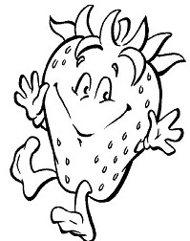 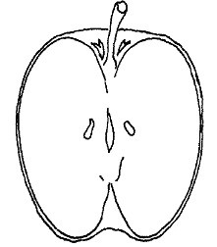 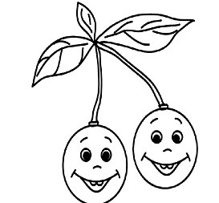

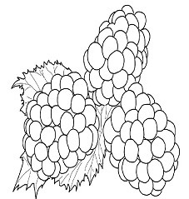 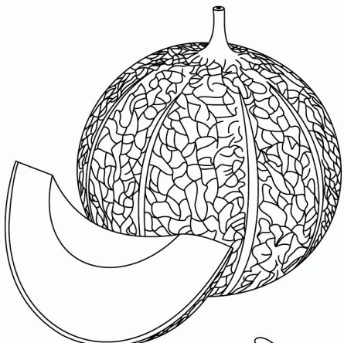 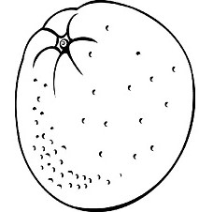

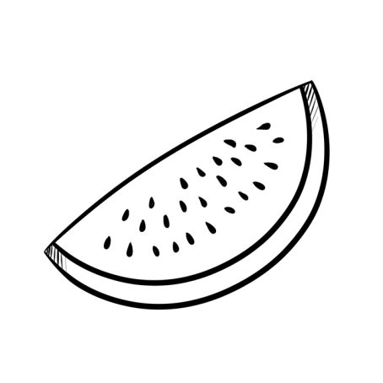 ONUR TÖRE