Hello.Good morning. My name is Kayla. What’s your name ?
Hello. Good morning. My name is Alex. Nice to meet you.

Look at example above and answer the questions.
Kayla: Hello………………..My ……………..What’s ……………..?
Alex:Hello…………………..My ……………...Nice……………….
Match the words with the pictures below.

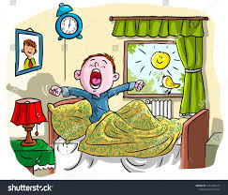 Good evening
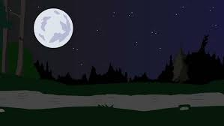
Good afternoon
Good evening
Good night
