ANIMALS
What is this? This is a CAT

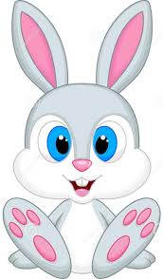 What is this? This is a rabbit.
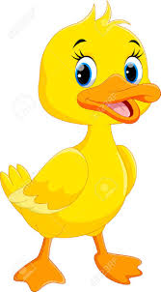 What is this?This is a duck.
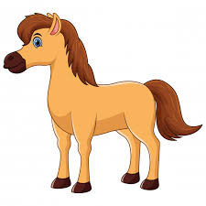 What is this?This is a horse.
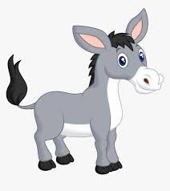 What is this?This is a donkey.

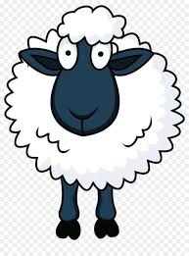 What is this?This is a sheep.

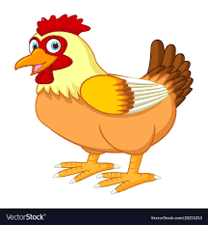 What is this? This is a hen.

What is this? This is a dog.

WHERE IS IT ? HOW MANY ?
IN- ON- UNDER
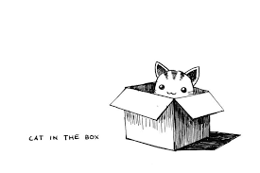Where is the cat ? The cat is IN the box.
How many cats ? One cat.
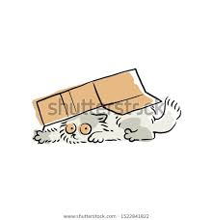Where is the cat ? The cat is UNDER the box.
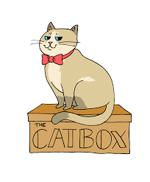Where is the cat ? The cat is ON the box.,
How many cats ? Two cats.

