Complete the sentences with can-can’t.

1-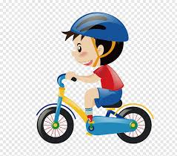 Alex ………. ride a bike.

2- The baby ……. swim.

3-Kevin ……. Run very fast.

4-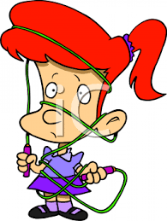 Linda …… skip rope.

5-Jay and Sofia ……. Jump.

6- Kay …….. play the guitar.

7-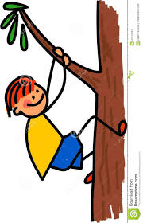 He …….. climb the tree.

