BİTİŞ | 4 X 3 | 5 X 3 | 5 X 2 | 3 X 2 | 4 X 4 | 4 X 3 | 4 X 2 | 4 X 3
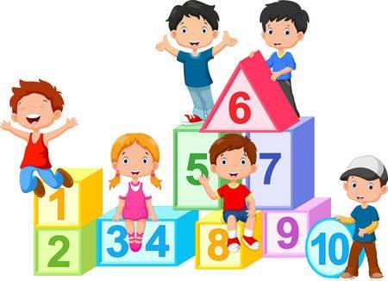  BAŞLAMA |  |  |  |  |  |  |  | 3 X 1
3 X 3 |  |  |  |  |  |  |  | 5 X 3
2 X 1 |  |  |  |  |  |  |  | 3 X 5
4 X 2 |  |  |  |  |  |  |  | 2 X 3
3 X 4 |  |  |  |  |  |  |  | 2 X 2
2 X 5 | 4 X 5 | 4 X 1 | 2 X 4 | 2 X 3 | 3 X 3 | 1 X 3 | 5 X 5 | 5 X 3

