AT THE PLAYGROUND
JUMP-JUMP-JUMP
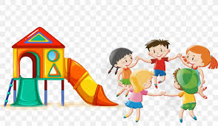 PLAY-PLAY-PLAY

SING-SING-SING

FLY A KITE-FLY A KITE-FLY A KITE

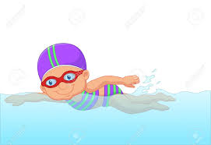 SWIM-SWIM-SWIM

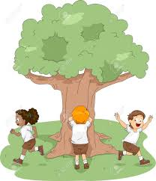 (PLAY)HIDE AND SEEK-HIDE AND SEEK-HIDE AND SEEK
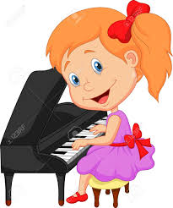 PLAY PIANO-PLAY-PIANO-PLAY PIANO
(PLAY GUITAR,VIOLIN ETC.)

PLAY FOOTBALL-PLAY FOOTBALL-PLAY FOOTBALL
(PLAY VOLLEYBALL,GOLF,TENNIS ETC.)

LET’S…………………..

I SING
I SKIP ROPE
I SWIM
I PLAYN GUITAR
I JUMP
ALWAYS- SOMETIMES
HER ZAMAN- BAZEN

DO YOU ………? Yes,I do/No,I don’t.

DO YOU SKIP ROPE ?
DO YOU PLAY FOOTBALL ?
DO YOU PLAY HIDE AND SEEK ?
DO YOU FLY A KITE ?
DO YOU SWIM ?

